Exp - 8
Aim
Cyclomatic Complexity Calculation Using Flow Graph
To calculate the Cyclomatic Complexity of a flow graph using the number of edges, nodes, and predicate nodes. Procedure
Step 1: Identify the values given in the problem.
• Number of Edges (E) = 17
• Number of Nodes (N) = 13
• Number of Predicate Nodes (P) = 5
Step 2: Apply the Cyclomatic Complexity formula:
��(��) = �� + 1
Step 3: Substitute the given values.
��(��) = 5 + 1
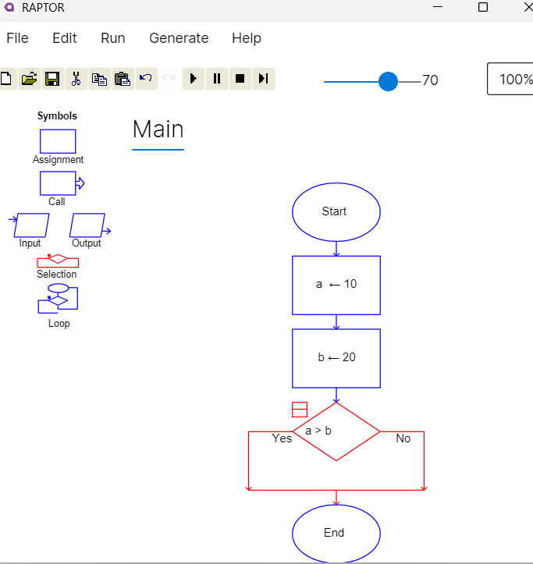

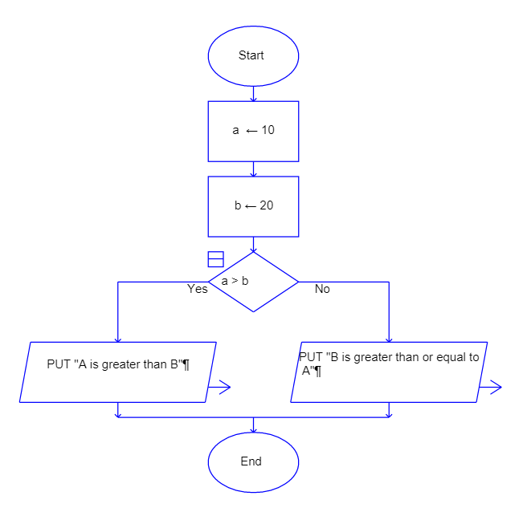

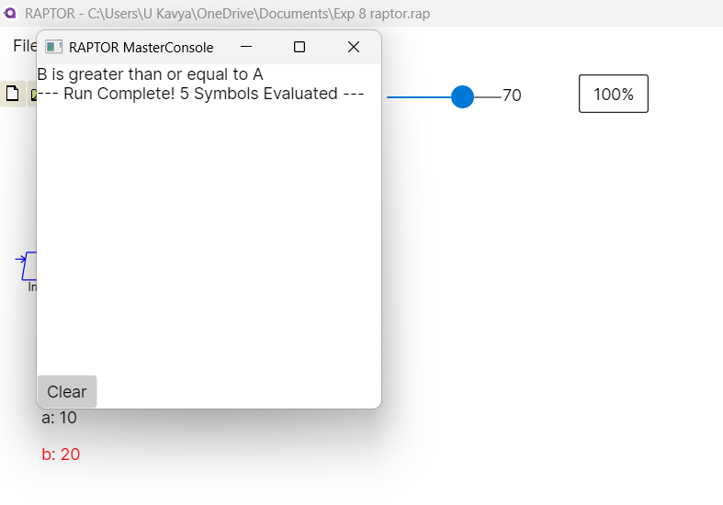

Result
Thus, the Cyclomatic Complexity of the given flow graph was calculated successfully and the complexity value obtained is 6.

